Logistic Regression on Breast Cancer Dataset

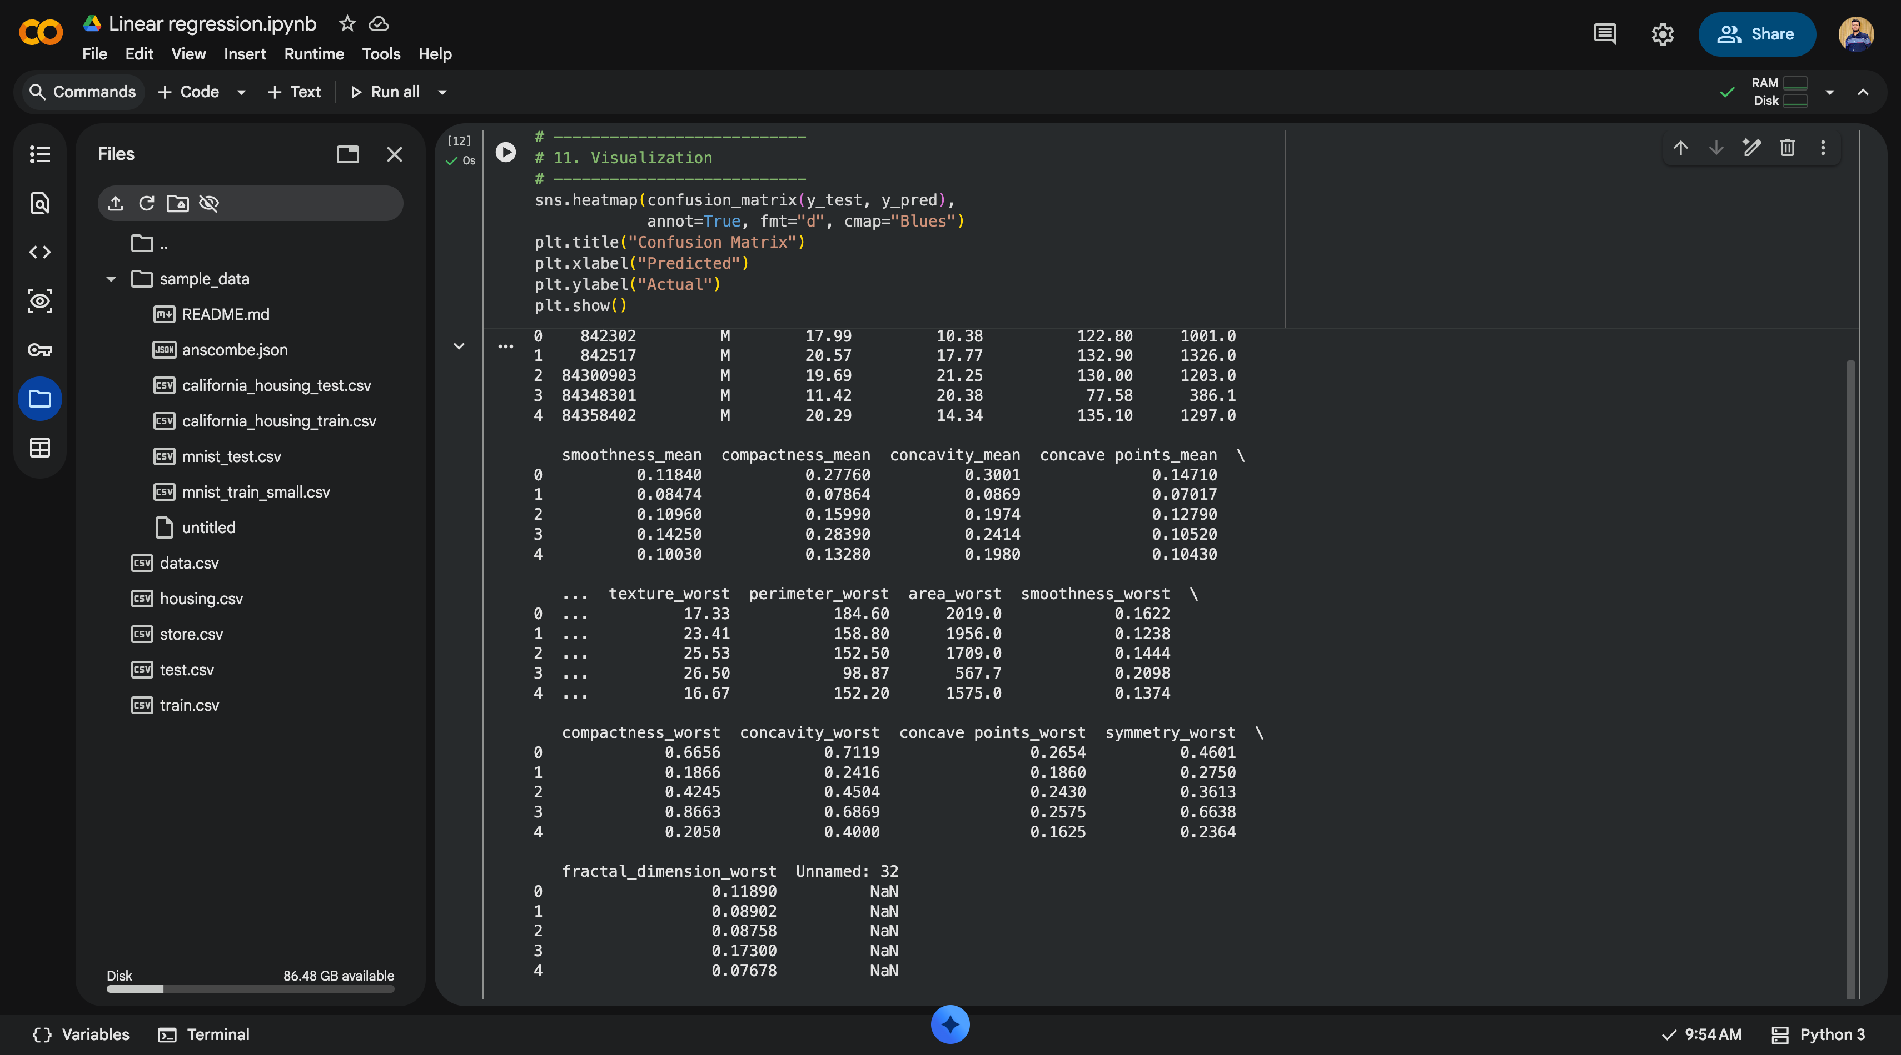

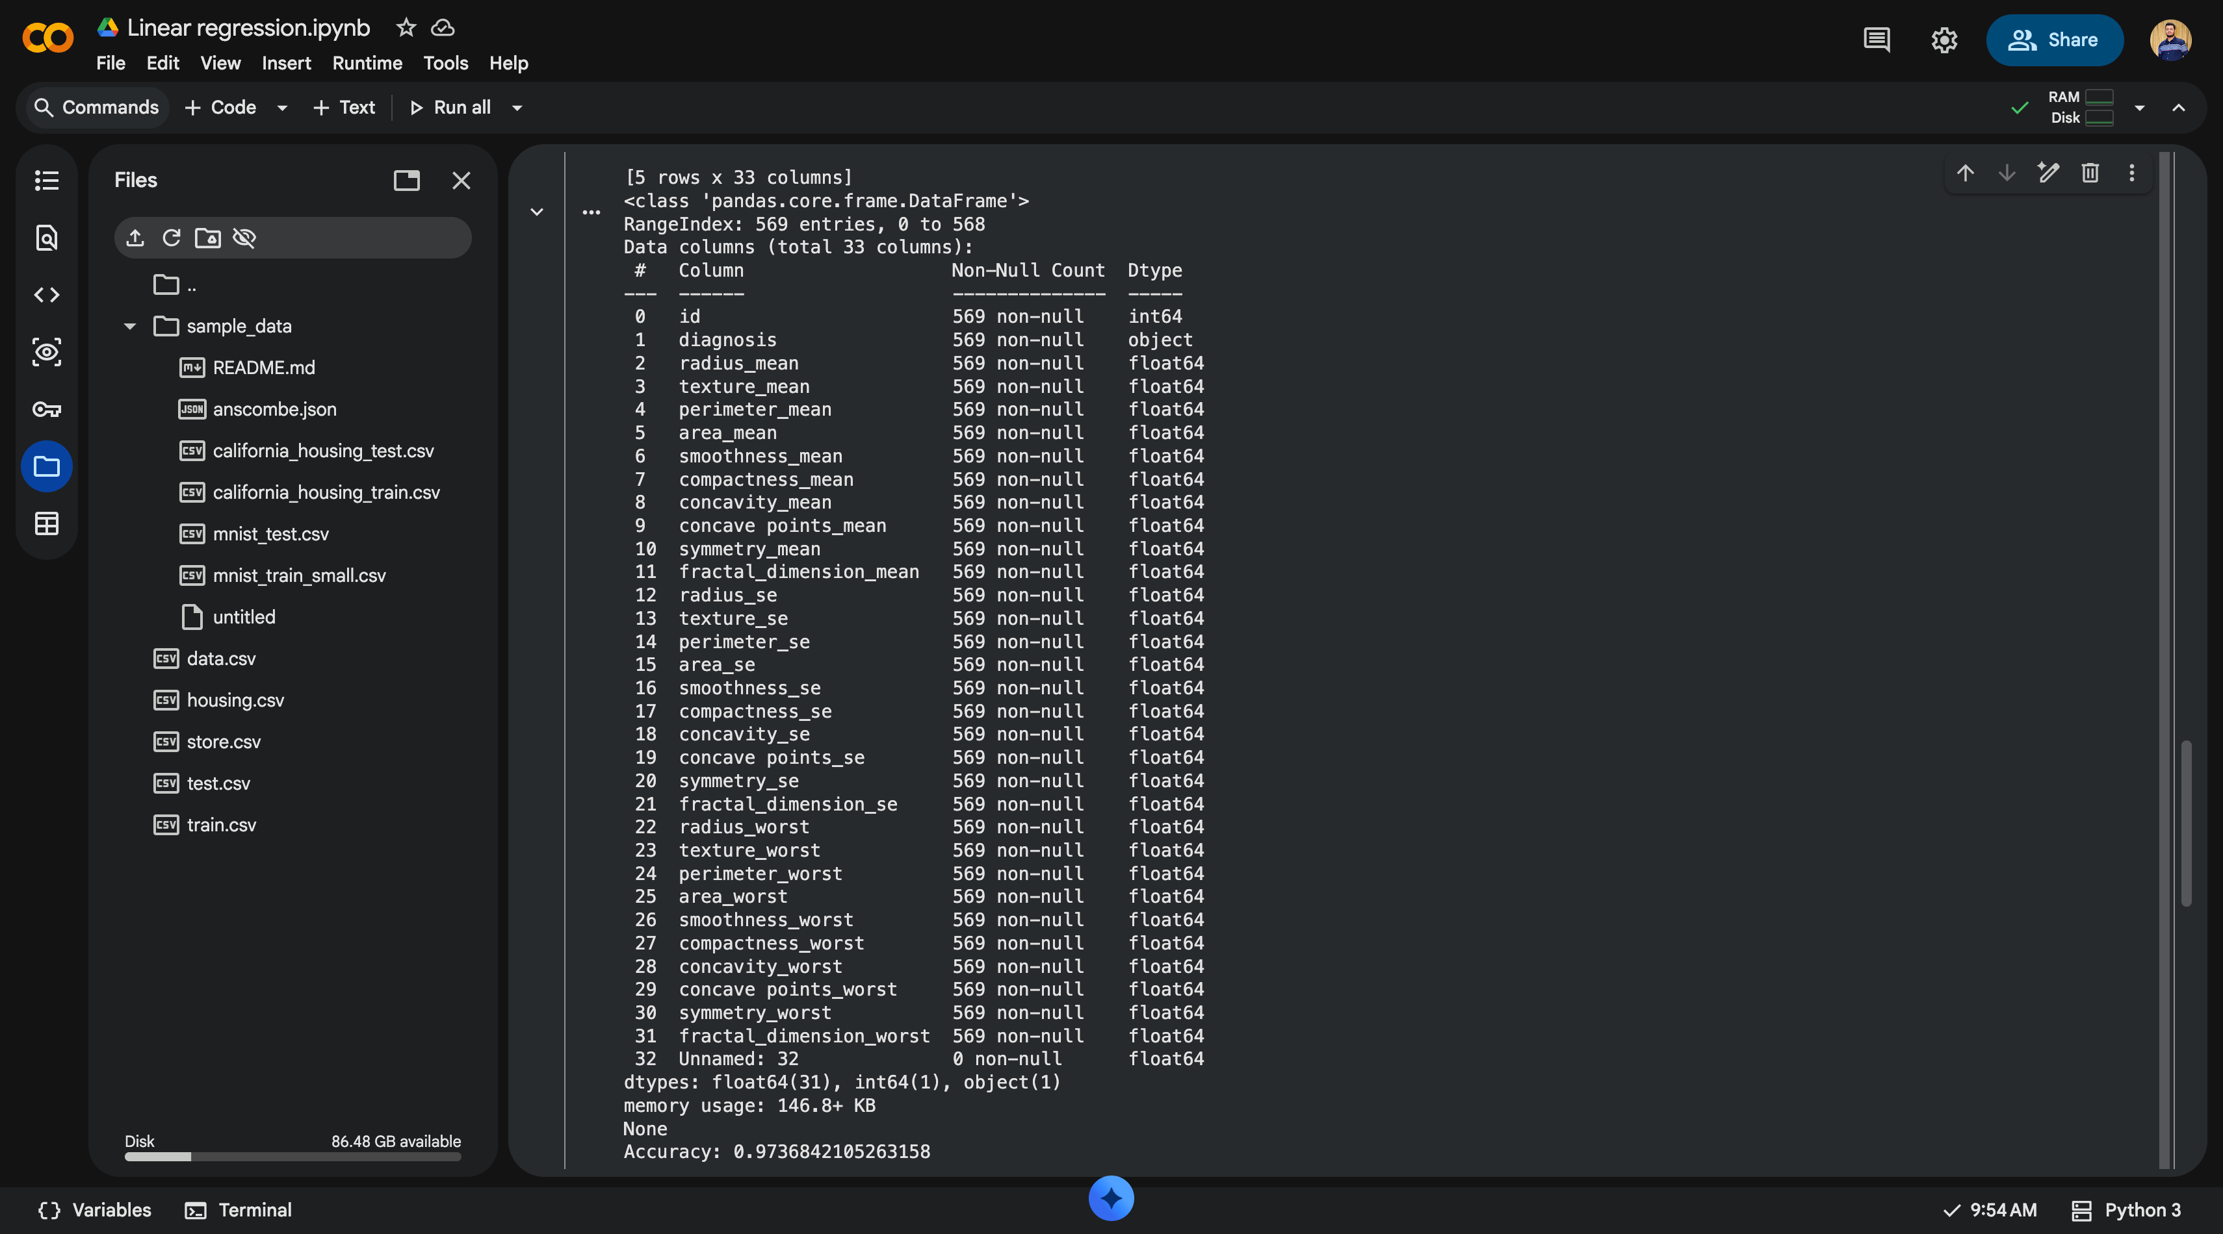

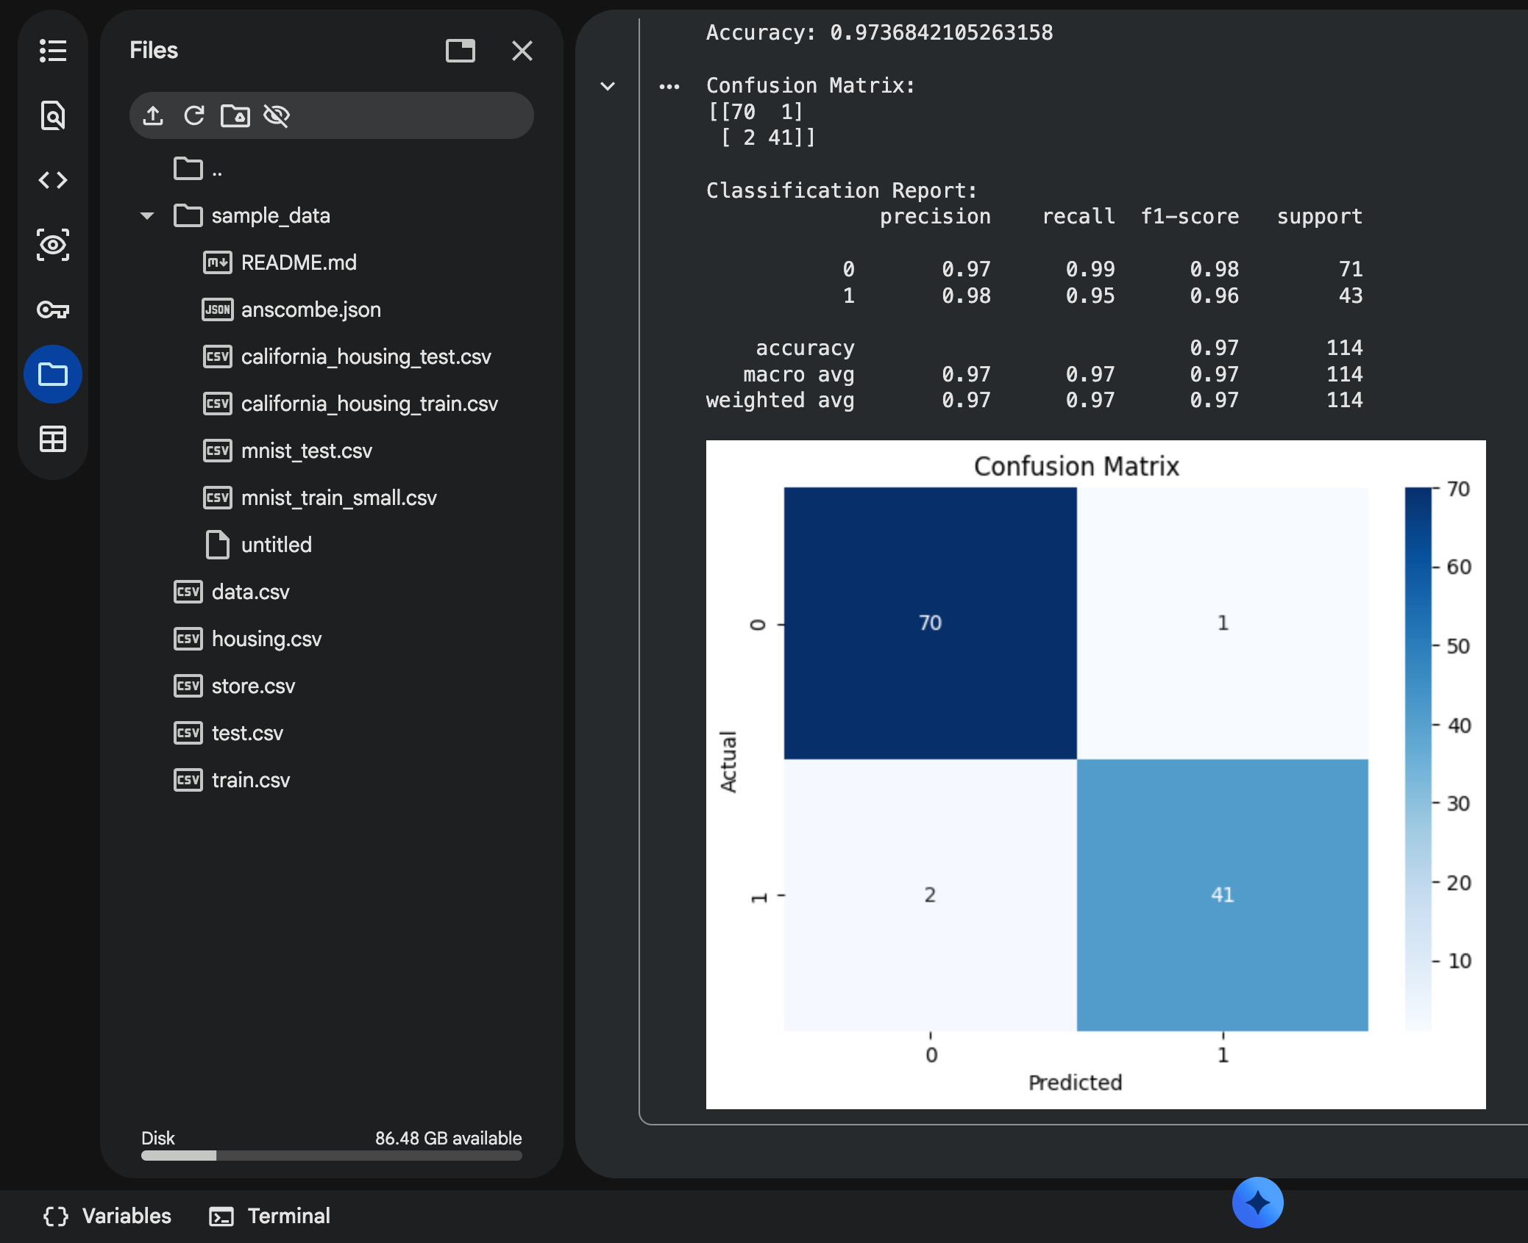

1. Dataset Source
The dataset used for this experiment is the Breast Cancer Wisconsin (Diagnostic) Dataset, available on Kaggle.
Dataset link:
👉 https://www.kaggle.com/datasets/uciml/breast-cancer-wisconsin-data
File used: data.csv (single CSV file)

2. Dataset Description
This dataset contains features computed from digitized images of breast mass biopsies.
The objective is to classify tumors as malignant or benign.

Dataset Size
Total records: 569
Total features: 30 numerical features
Target variable: Diagnosis (Binary classification)
File size: ~120 KB

Features (Examples)
radius_mean
texture_mean
perimeter_mean
area_mean
smoothness_mean
concavity_mean
symmetry_mean
(All features are numerical and represent tumor characteristics.)

Target Variable
diagnosis
M → Malignant (Cancerous)
B → Benign (Non-cancerous)

Characteristics
Clean dataset (no missing values)
Binary classification problem
Suitable for Logistic Regression

3. Mathematical Formulation of Logistic Regression
Logistic Regression models the probability that a given input belongs to a particular class.

Hypothesis Function (Sigmoid)
h(x) = \frac{1}{1 + e^{-(\beta_0 + \beta_1 x_1 + \dots + \beta_n x_n)}}

Decision Rule
\text{If } h(x) \ge 0.5 \Rightarrow \text{Class = 1}
\text{Else } \text{Class = 0}

Cost Function (Log Loss)
J(\beta) = -\frac{1}{n} \sum [y \log(h(x)) + (1-y)\log(1-h(x))]
The algorithm minimizes log loss using optimization methods such as gradient descent.

4. Algorithm Limitations
Assumes linear decision boundary
Performs poorly on non-linearly separable data
Sensitive to outliers
Requires feature scaling
Not suitable for multi-class problems without extensions

5. Methodology / Workflow
Steps followed in the experiment:
Load dataset from CSV
Drop unnecessary columns (id)
Encode target labels (M, B)
Feature scaling using StandardScaler
Train-test split (80/20)
Train Logistic Regression model
Predict test data
Evaluate performance
Workflow:
Dataset → Preprocessing → Scaling → Train-Test Split → Model Training → Evaluation

6. Performance Analysis

Evaluation Metrics
Accuracy
Confusion Matrix
Precision, Recall, F1-score

Typical Results
Accuracy: ~95% – 98%
High precision and recall indicating excellent classification performance

Interpretation
Model correctly identifies most malignant cases
Very few false positives/negatives
Logistic Regression performs well due to clear feature separation

7. Hyperparameter Tuning

Tuned Hyperparameters
C (Regularization strength)
penalty (l2)
solver (liblinear)

Impact
Regularization reduces overfitting
Proper tuning improves generalization
Scaling significantly improves convergence

# Logistic Regression on Breast Cancer Dataset

import pandas as pd
import numpy as np
import matplotlib.pyplot as plt
import seaborn as sns

from sklearn.model_selection import train_test_split
from sklearn.preprocessing import StandardScaler, LabelEncoder
from sklearn.linear_model import LogisticRegression
from sklearn.metrics import accuracy_score, confusion_matrix, classification_report

# ---------------------------
# 1. Load dataset
# ---------------------------
df = pd.read_csv("data.csv")

print(df.head())
print(df.info())

# ---------------------------
# 2. Drop unnecessary columns
# ---------------------------
df = df.drop(columns=["id", "Unnamed: 32"], errors="ignore")

# ---------------------------
# 3. Encode target variable
# ---------------------------
le = LabelEncoder()
df["diagnosis"] = le.fit_transform(df["diagnosis"])
# M = 1, B = 0

# ---------------------------
# 4. Features & target
# ---------------------------
X = df.drop("diagnosis", axis=1)
y = df["diagnosis"]

# ---------------------------
# 5. Feature scaling
# ---------------------------
scaler = StandardScaler()
X_scaled = scaler.fit_transform(X)

# ---------------------------
# 6. Train-test split
# ---------------------------
X_train, X_test, y_train, y_test = train_test_split(
X_scaled, y, test_size=0.2, random_state=42
)

# ---------------------------
# 7. Logistic Regression model
# ---------------------------
model = LogisticRegression(
max_iter=1000,
solver="liblinear",
C=1.0
)

# ---------------------------
# 8. Train model
# ---------------------------
model.fit(X_train, y_train)

# ---------------------------
# 9. Predictions
# ---------------------------
y_pred = model.predict(X_test)

# ---------------------------
# 10. Evaluation
# ---------------------------
accuracy = accuracy_score(y_test, y_pred)
print("Accuracy:", accuracy)

print("\nConfusion Matrix:")
print(confusion_matrix(y_test, y_pred))

print("\nClassification Report:")
print(classification_report(y_test, y_pred))

# ---------------------------
# 11. Visualization
# ---------------------------
sns.heatmap(confusion_matrix(y_test, y_pred),
annot=True, fmt="d", cmap="Blues")
plt.title("Confusion Matrix")
plt.xlabel("Predicted")
plt.ylabel("Actual")
plt.show()

Conclusion
Logistic Regression was successfully applied to the Breast Cancer dataset for binary classification. Due to well-separated features and proper scaling, the model achieved high accuracy and reliable predictions. Logistic Regression proves to be an effective and interpretable algorithm for medical classification problems.

